**Computer Selection Assignment**

Machine Chosen: Alienware Area-51 Gaming PC

This is a gaming PC made by Dell. The cost of it is high as well since it is a gaming pc which requires better parts such as a good graphics card, etc. Also because of the brand being well-known increases the price factor as well.

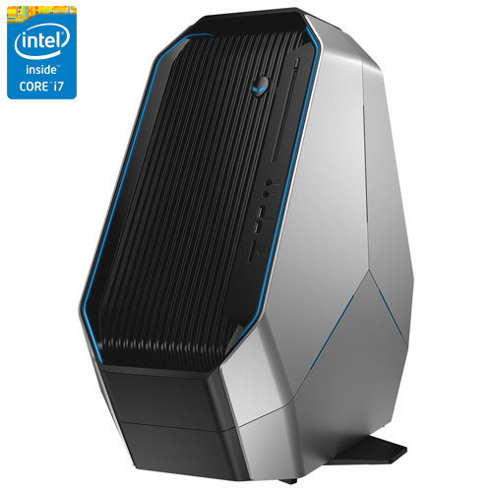



1. $$$ Cost of the machine.

The cost of the machine is 2,999.99 Canadian dollars plus tax.

2. Central Processor type and speed

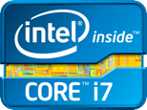The processor works with the other parts of the computer to help with tasks such as playing games, using the web, etc. There are 2 main types of processors which are AMD and Intel. The machine I chose has an Intel Core i7-58280k processor. The processor speed is 3.3 GHz (gigahertz).

3. Graphics Processing Unit (GPU) speed

The GPU is a chip that renders images shown on the computer through fast mathematical calculations. The GPU speed for this computer is 1050 MHz (megahertz).

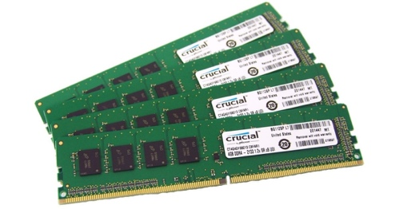

4. Random Access Memory (RAM) speed, size

The RAM is a temporary storage that stores the files that are currently being used on your computer. This computer I chose has a RAM size of 16GB and speed of 2133 MHz (megahertz).

5. Storage memory (Hard drive) speed, size

The hard drive size is the amount of space available to store things such as programs, documents, pictures, etc. The hard drive size for this pc is 2TB (terabytes). The hard drive speed is the speed at which the computer can access the information such as documents and other data. The hard drive speed for this computer is 7200 rpm (revolutions per minute).

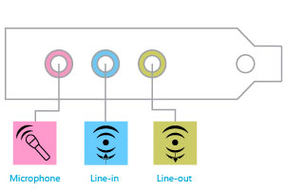

6. Input/Output devices

The input devices mentioned are keyboard, mouse, card readers, Line-in and Mic-in. The output devices consist of the HDMI output, Line Out, and speakers.

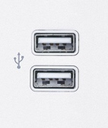

7. Ports

There are a total of 10 USB ports, Ethernet port, and the audio ports in the computer

8. Networking

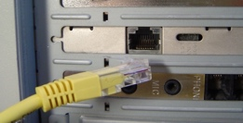This computer has an Ethernet port to be able to use a wired network connection. It also has integrated Wi-Fi which removes the need of buying a Wi-Fi adapter to connect to your internet wirelessly. Furthermore, it also has integrated Bluetooth meaning you would be able to connect things such as wireless keyboards, mice, etc.

9. Sound Card, speakers

There are built-in speakers for this device meaning that there is no need for external speakers to be connected. The sound card for this computer which enhances the audio quality is Sound Core3D.

10. Case and Power Supply

The case for this machine has a colour of Epic Silver. It has a width of 27.26cm, a height of 56.92 cm, and a depth of 63.89cm. The weight of the machine is 27.77kg. There is a 330W power cord that is used for the power supply.

11. Operating System

The operating system for this computer is Windows 10 (if buying from Best Buy) which is pre-installed in the device. If I was buying the pc from the original website of Alienware I would customize my pc and change Windows 10 to 8 with an additional of $70 because I prefer Windows 8 over 10.

